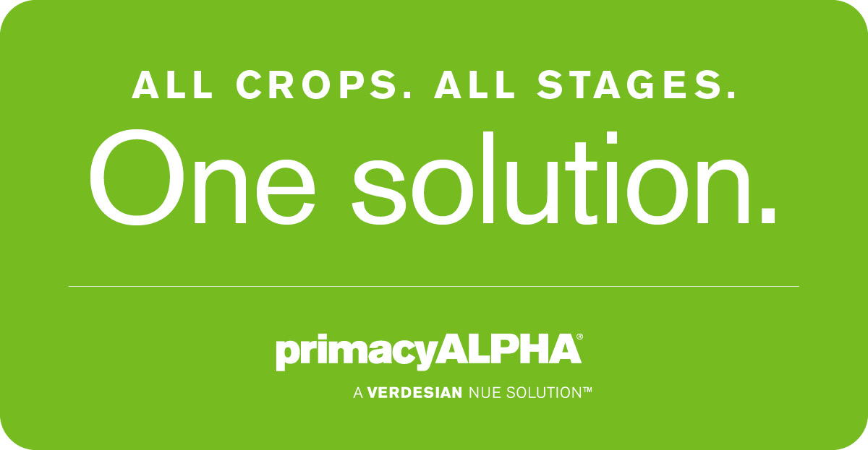
This time of year, you have plenty of things on your to-do list. Why not put your mind at ease by using a nutrient enhancer that works with all crops at all stages: Primacy ALPHA®.
Primacy ALPHA works inside the plant to stimulate the efficient assimilation and utilization of nutrients. It also functions as a reproductive growth catalyst that collectively stimulates, intensifies and optimizes plant metabolism; encourages rapid plant nutrient uptake; promotes plant growth; and enhances consistent crop quality and yield potential. The best part? Primacy ALPHA is so easy to use. Versatile in both soil and foliar applications and compatible with commonly used fertilizers and pesticides, Primacy ALPHA is a critical part of your fertility program, with proven performance on a wide range of crops including cereals, alfalfa, tree nuts, grapes, citrus, strawberries, brassica crops and fruiting vegetables.
A nutrient enhancer that works on all crops at all stages? That sounds like piece of mind to us. Talk to your local ag retailer to learn more about Primacy ALPHA.

