Subject line: See the SEED+ GRAPHITE difference
Still not convinced about the performance of SEED+™ GRAPHITE nutritional seed treatment? Don’t take our word for it. Check out these results from third-party trials across geographies and crops.
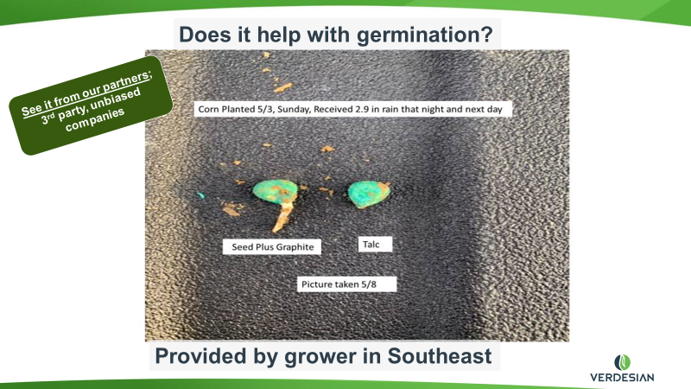
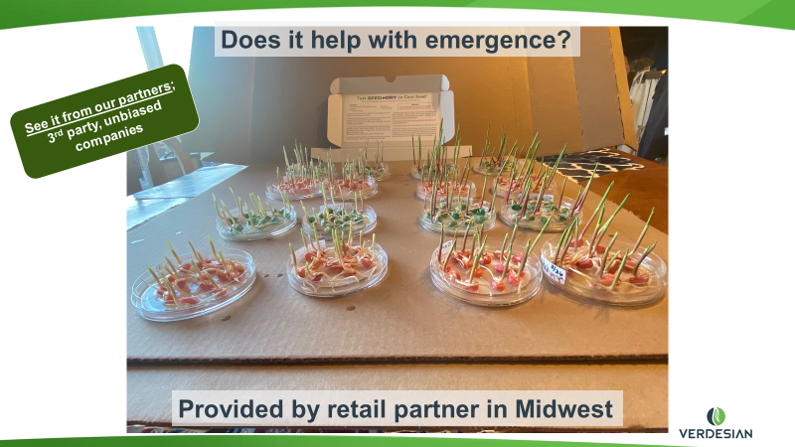

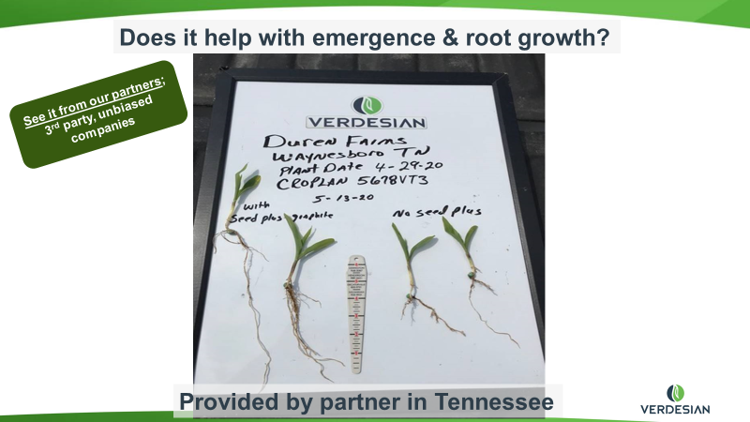

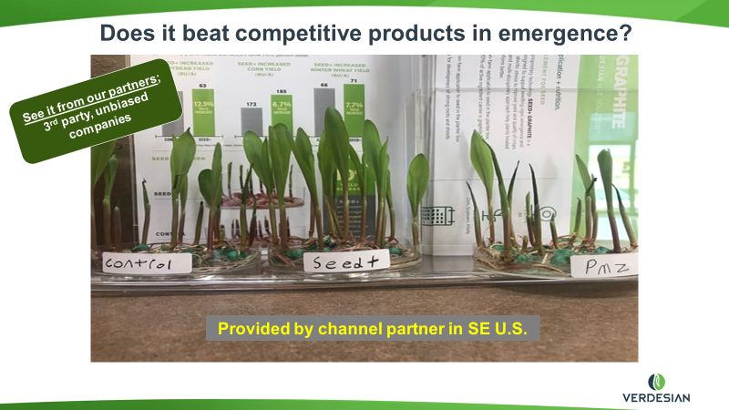
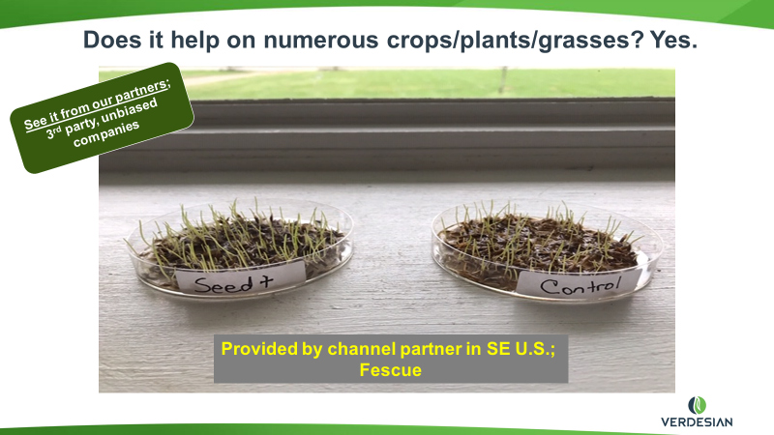

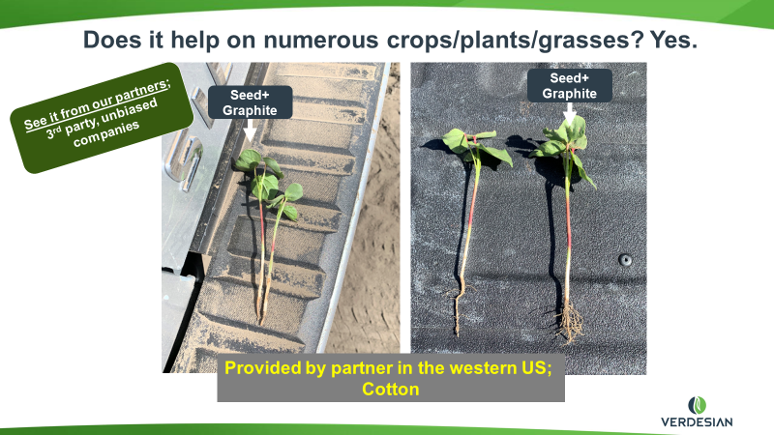

Visit https://www.vlsci.com/products/seed-plus or talk to us to learn more about how to incorporate SEED+ GRAPHITE into your operations.

