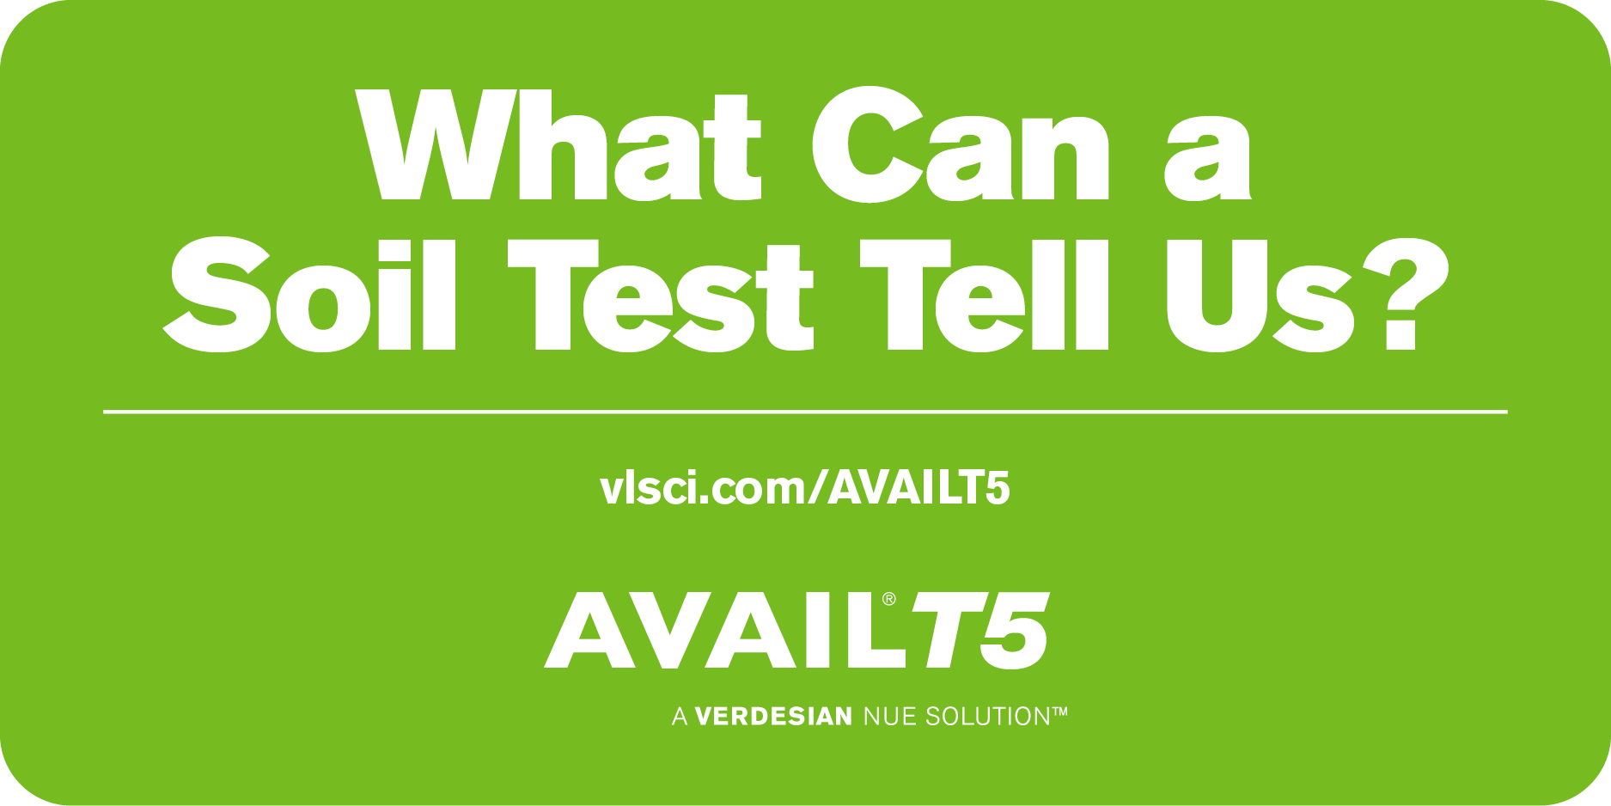
How do you know that you’re getting the most out of your P investment? The AVAIL T5 Placement Chart can help pinpoint fields & soil zones that stand to benefit from AVAIL T5, which unlocks P that’s fixed in the soil. Visit vlsci.com/AVAILT5 or reach out to us.

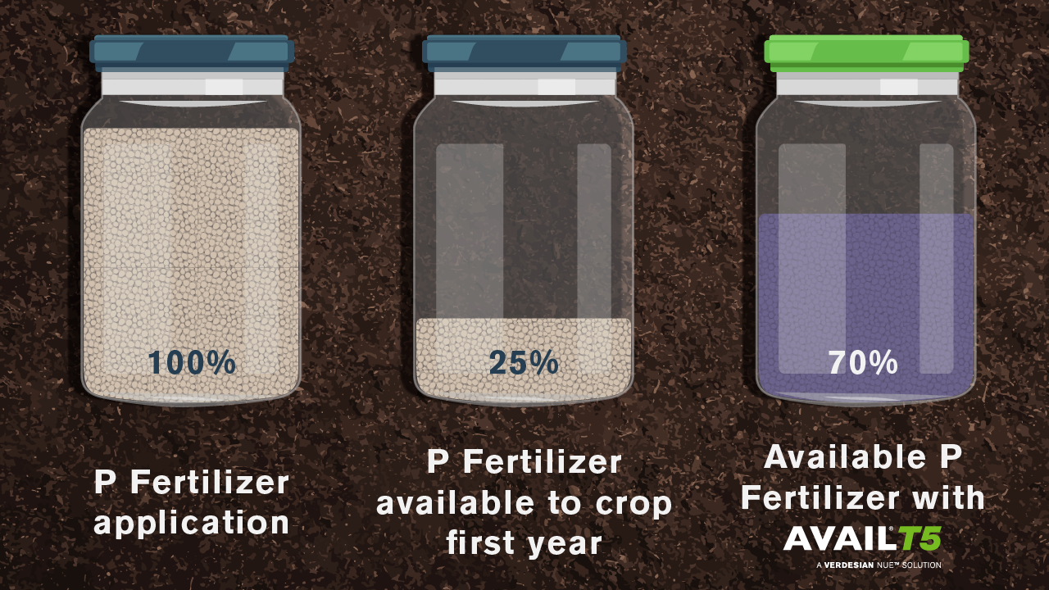

AVAIL® T5 Phosphorus Enhancer technology results in 30-45% more phosphorus being made available to the crop, according to field trials. Learn more vlsci.com/AVAILT5 or talk to your ag retailer today.

